**Angular** **Challenge**

1- First of all when i try to run the app with the line command **ng serve** I got this error in the terminal **could not find module “@angulardevkit/build-angular**

So i resolved it by running => **npm install** all modules listed in **package.json**

2- Add new component => **ng generate component** statistics/occupancy (under statistics)

3- Update the file **app.route.ts**, to add occupancy component route.

*export const routes: Routes = [*

*{ path: '', redirectTo: '/homepage', pathMatch: 'full' }, // default*

*{ path: 'about', component: AboutDemoComponent },*

*{ path: 'homepage', component: HomePageDemoComponent },*

*{ path: 'occupancy', component: OccupancyComponent },*

4- Edit **application-menu** (application-menu.demo.html) component to add occupancy entry to the menu.  
*<****div*** *class="accordion-header"><****a*** *href="javascript:void(0);"><****span****>Statistics</****span****></****a****></****div****>*

*<****div*** *class="accordion-pane">*

*<****div*** *class="accordion-header list-item"><****a*** *[routerLink]="['occupancy']"><****span****>Occupancy</****span****></****a****></****div****>*

*</****div****>*

5- Next, i start to create the datagrid (reuse the soho datagrid) => i create the occupancies array of objects and initialize it with data to show it in the grid (the header zone) => in this file **occupancy.component.ts**

**occupancies: Object[];**

columns: SohoDataGridColumn[] = [

{ id: 'date', name: 'Date', field: 'date', sortable: false, width: 50},

{ id: 'capacity', name: 'Capacity', field: 'capacity', width: 50},

{ id: 'occupancy', name: 'Occupancy', field: 'occupancy', width: 50} ];

6- Initalize occupancies array with data in the constructor.

this.occupancies = [];

this.occupancies.push({ date: '10/11/2015', capacity: 100, occupancy: 41});

….

7-In the **occupancy.component.html**, add the **soho-datagrid** as a div :

<div soho-datagrid

[columns]="columns"

[data]="occupancies"

[selectable]="'single'"

[paging]="true"

[pagesize]="4"

[treeGrid]="true">

</div>

Below, the datagrid created with pagination, 4 records per page.

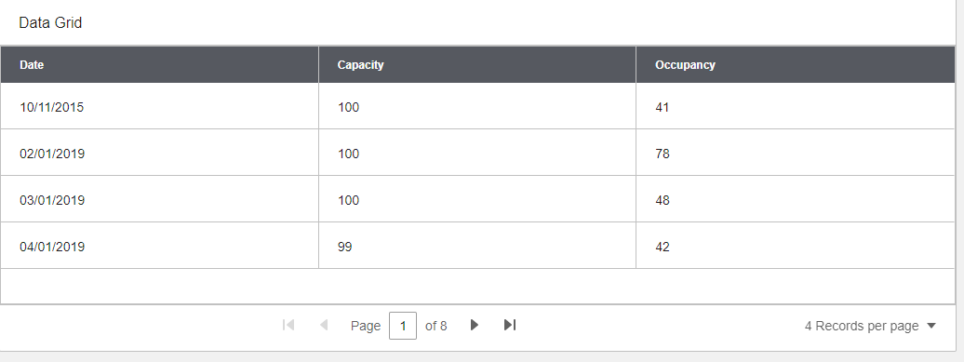

8- To show the Chart line: below the steps to create it :

In the **occupancy.component.ts**, I declare a chartLineData array and fill it with json data.

chartLineData = [

{

data: [

{

name: '01/01/2019',

value: 100, depth: 4

},

….….

{

name: '31/01/2019',

value: 100

}

],

name: 'Capacity',

color: 'blue'

}, {

data: [

{

name: '01/01/2019',

value: 41

},

………….

{

name: '31/01/2019',

value: 75

}

],

name: 'Occupancy',

color: '#f05e23'

}

];

For the xAxes, i will expose the dates with odd day values.

The capacity values is colored in blue and the orange is for occupancy values.

In the **occupancy.component.html**, i reuse the soho-line component created in the **[enterprise-ng](https://github.com/infor-design/enterprise-ng)**

<div class="widget-content">

<div soho-line class="chart-container"

[dataset]="getLineChartData()"

showLegend="true"

[xAxis]="xAxis"

[yAxis]="yAxis"

hideDots="true"

type="spline">

</div>

